|  |
| --- |
| **Printer configuration** |

1 General info 2

2 MFP's 3

2.1 DNS record creation 3

2.2 Folder creation 3

2.3 Configure scanning 4

3 Printer specific settings 5

3.1 HP M477fdn 5

3.2 Printers that aren't listed 5

# General info

Naming of the printers should be done according to the naming convention.  
For ships:

(<Vessel abbreviation>-<Printer type>-<Printer location>[Optional number]).  
For sites

(<Site abbreviation>-<Printer type>-<Optional number>).

Printer type:

PRI = Printer

MFP = Multifunctional

LBL = Labelprinter/Zebra

For example: KE-PRI-BRIDGE01 = first printer on the bridge of the Kaerius.

The printers should be connected to a 'crewlan' port on the switch. As soon as the printer has received an IP address, you can go into the DHCP console and create a reservation for the current lease.

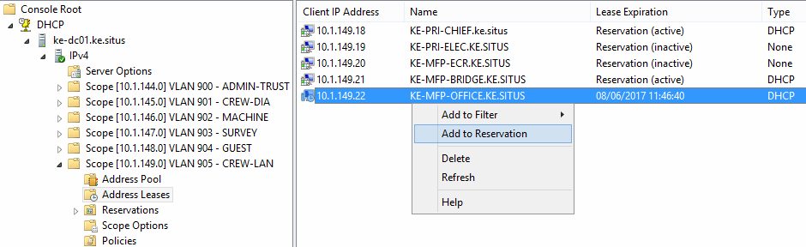

Make sure to rename the reservation in case it's still using the default printer name.

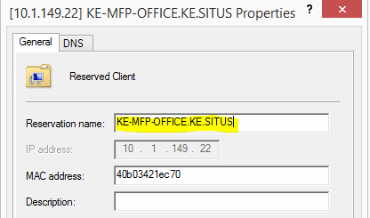

# MFP's

When a multifunctional printer is being used, you'll have to create a shared folder on the fileserver to which the MFP can scan.

## DNS record creation

First, you'll have to create a CNAME record in DNS for each MFP.

Name this record (Ship name)-MFP<Number>-S2F

* For example: AI-MFP01-S2F, AI-MFP02-S2F, …

The FQDN should be the full name of the MFP for which you're creating this record.

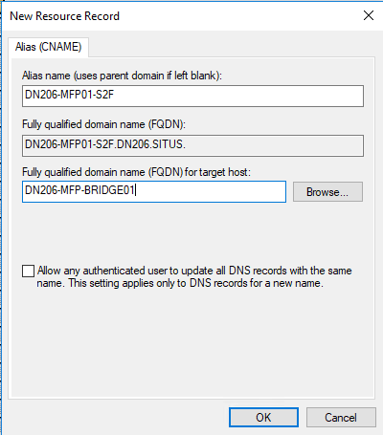

## Folder creation

After the DNS record has been created, you can create the required share(s) on the fileserver:

Usually, we'll only need a public scan folder:

* \\<Vessel abbreviation>-File01\data\APPDATA\SCANS

If requested, you can also create private folders:

* \\<Vessel abbreviation>-File01\data\USERDATA\<USER>_PRIV\SCANS

## Firewall config

To enable traffic from the scanner to the fileserver, new rules will have to be added on the firewall. Create a ticket for SA/SE to create the necessary firewall policies.

## Configure scanning

To configure the scan folder on the printer, surf to the printer's IP address in a web browser and navigate to the tab 'Scan' 🡪 'Scan to Network folder' 🡪 'Network folder setup' and click on the 'New' button

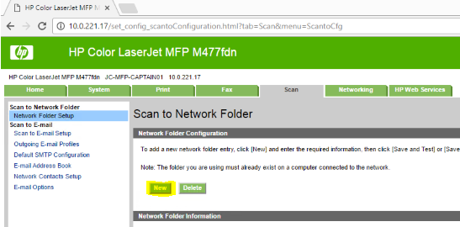

Fill in the following fields:

* Display Name: The name of the shortcut on the printer screen (eg. SCANS)
* Network path: the full path to the scan folder (eg. \\<Vessel abbreviation>-File01\data\APPDATA\SCANS)
* Username: srv_scan@<vessel abbreviation>.situs
* Password: the password matching the srv_scan account

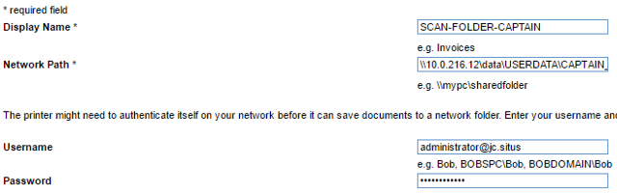

Keep the other settings default and click 'Save and Test'. If everything has been set up correctly, the test should succeed. If it doesn’t, make sure you're using the right username/password, the DNS record was created correctly and the permissions on the shared folder are ok.

# Printer specific settings

## HP M477fdn

* Home: Keep default
* System 🡪 Device information:
  + Fill in Device description (Printer name according to naming convention)
  + Fill in Asset number (JDN tag)
  + Fill in Company Name (Jan De Nul Group)
  + Fill in Device Location (<Vessel name> - <Location/User>)
  + Keep other System settings default
* Print: keep default
* Fax: keep default
* Scan
  + Network folder setup: see step 2 - MFP's
  + Keep all other scan settings default (mail, network, ...)
* Networking
  + Network identification: fill in correct host name (printer name)
  + Keep all other network settings default
* HP web services: Keep default

## Printers that aren't listed

If you're configuring a printer that isn't listed here, check with one of your colleagues to see if there are any other settings you should adjust. Feel free to update the documentation accordingly afterwards.

# AMOS label printers

## Zebra label printers

* Add on TCP/IP on the file server, when prompted to specify a network card, leave default and click next.
* Always use the ‘ZDesigner GK420t driver for windows’. (using other drivers may cause the print spooler to crash)
* Add the ‘ AMOSW’ stock and set it as default for all label printers on XX-FILE01’s print management:
* Right-click the printer and choose ‘Advanced’ -> ‘printing defaults’
* Under ‘stocks’ create a new stock and name it ‘ amosW’ INSERT BLANK SPACE IN FRONT.
* Set the label size to “101,6mm x 26,6mm”, set the darkness to 25 and save it.
* Under ‘options’ set the default stock to ‘ amosW’.
* Repeat for all label printers.

**Note:** When sending printers, don’t leave the labels in the device, but package them separately instead. (during shipping, this may damage the holders)

# Drivers

## Printer drivers

* Always use generic printer drivers (see the example below), such as HP universal PCL 5. (works for m477fdn, laserjet m400, ...)
* Never install the full executables that come in driver packages, this may cause issues with appsense on the clients.

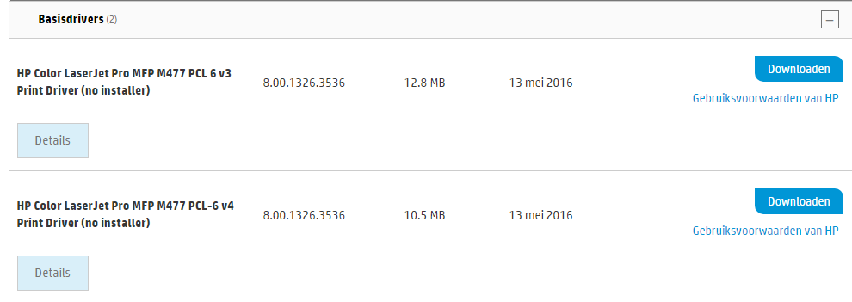

# Printserver

## Adding the printer

* Place the driver somewhere accessible for the file server (e.g. \\X-file01\DATA\USERDATA\IT).
* Go to Print Management , Print Servers < X-File01 < Printers < Add printer...
* ‘Add a TCP/IP or Web Services Printer by IP address or hostname’
* Choose TCP/IP Device in the dropdown and deselect ‘Auto detect the printer driver to use’. Fill in the printer’s IP and click ‘next’.

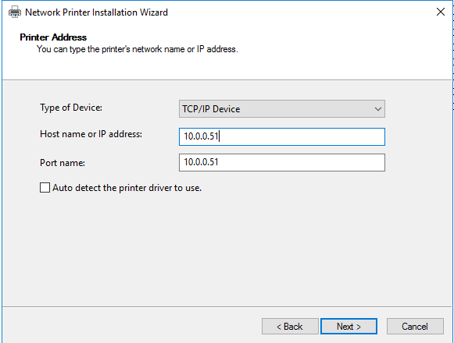

* Select ‘Have Disk...’ and browse to the driver. If multiple drivers are found, pick the largest.

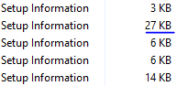

* Choose to replace the current driver and give the printer the correct name.
* Share the printer and give it the same name with the correct location.
* If possible print a test page.